**PERSONAL PROFILE**

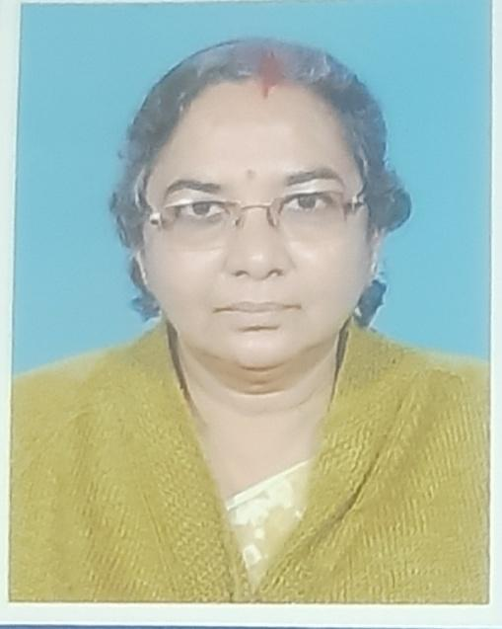

**Name : Mrs SAILEE MUKHERJEE**

**Designation : Associate Professor in Bengali**

**Date of Birth : 12/03/1960**

**Educational Qualification : MA JRF Scholar. Phd undone for sevier illness.**

**Present Address : Rabindrapalli, Suri, Birbhum, PIN –731101**

**Permanent Address : Same as above state**

**Contact Number : 9434635565**

**E-mail :** [**saileegoswami@gmail.com**](mailto:saileegoswami@gmail.com)

**Date of Joining in Higher Education : 28/10/1987**

**Teaching Experience : 37 years+**

**Area of Teaching : Medieval Bengali Literature**

**Specialization during PG Level : Rabindranath : life and works**

**Associated With Any Other Social Organization : LAL MATIR DESH**

**Other Academic activities : Special class in online and off line mode taken regularly**

**Direct participation at college programmes in last five years : Participated in every cultural programme.**

**Achievements :**

**OP/RC/SUMMER SCHOOL ATTENDED: One OP & Three RC done before the stage of Associate Professor : Have done.**

**PAPER/ POSTER/ ORAL PRESENTED AT STATE LEVEL/ NATIONAL/ INTERNATIONAL SEMINARS/ WORKSHOPS: yes, i will provide those certificates when necessary.**